6. Event Registration Form - Zoho Creator Command Center Page
Aim:
To design and build a single internal "Command Center" Page in Zoho Creator for the "Event
Registration Form" application, demonstrating the use of Page Builder elements (Panel, Board, Chart, Gauge, Search, Form, Report, Snippets, Button, Widgets, and Viewer) to provide one unified workspace to monitor and manage event registrations.

Page Elements Used
Page Element Type | Element Name
Panel | Event_Command_Center_Main_Panel
Board | Event_Registration_Status_Board
Chart | Event_Popularity_Chart_Widget
Gauge | Event_Registration_Target_Gauge
Search | Participant_Search_Bar
Form | Quick_Event_Registration_Form
Report | Full_Event_Registrations_Report
Snippets | Event_Preparation_Checklist_Snippet
Button | Send_Event_Reminder_Button
Widgets | Event_Capacity_And_Registration_Stats_Widgets
Viewer Event_Details_Viewer

Page Layout (Section-wise)
- Section 1: Overview Strip – Event Registration Target Gauge (Gauge element), Event Popularity Chart (Chart element), and Participant Search Bar (Search element).
- Section 2: Registration Workspace – Send Event Reminder Button (Button element) and Registration Status Board (Board element).
- Section 3: Detailed Data – Full Event Registrations Report (Report element).
- Section 4: Reference & Quick Actions (Sidebar) – Event Preparation Checklist Snippet (Snippets element), Event Details
Viewer (Viewer element), and Quick Event Registration Form (Form element, expandable tab).
- Section 5: Operations Strip – Event Capacity and Registration Statistics Widgets (Widgets element).
- Note: All sections are arranged within the
Event_Command_Center_Main_Panel, which acts as the main structural Panel for the page.
Screenshots:
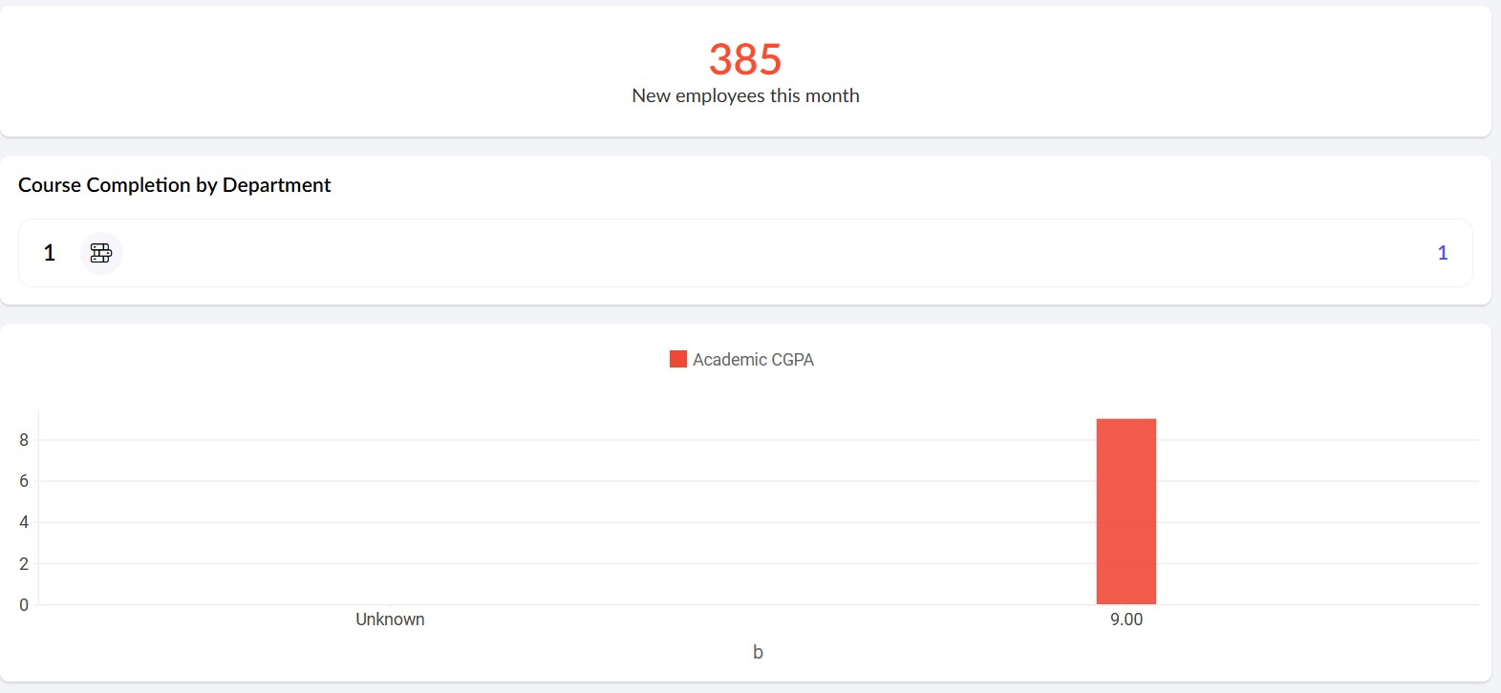

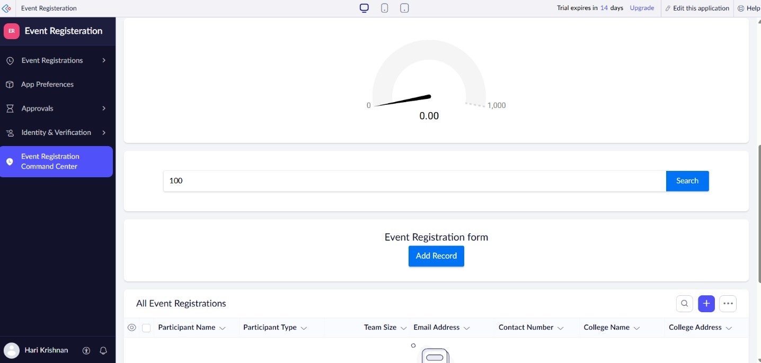

Result:
A single internal "Command Center" Page in Zoho Creator for the Event Registration Form application is created to monitor and manage event registrations.

